Hands-on Exercise No. 4
DigiSkills 3.0 Batch-02
Data Analytics & Business Intelligence

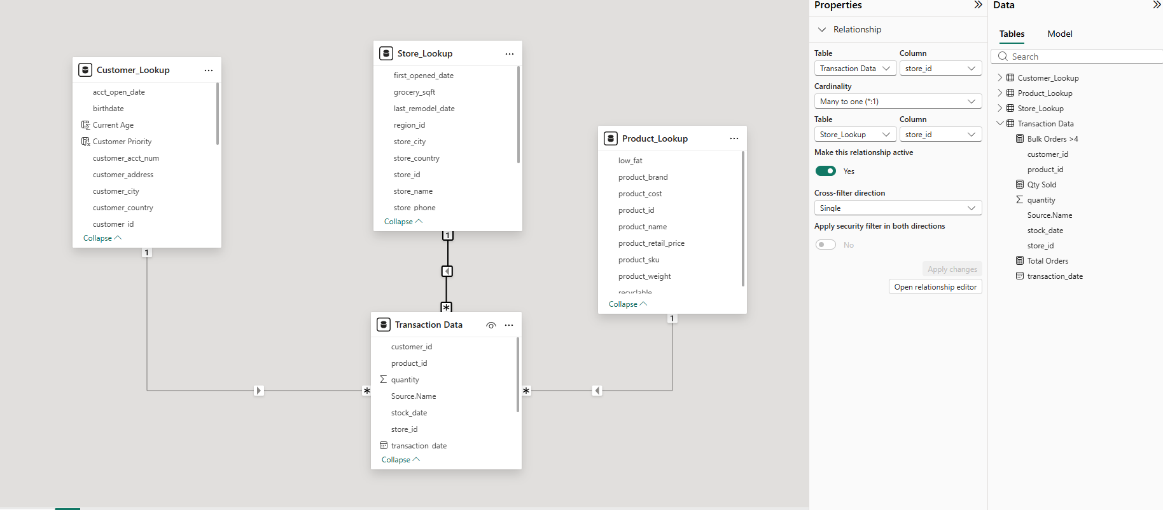

Report & Visualization Tasks
Create a Report View page named Summary and design visuals using Customer_Lookup
and Transaction Data tables. Add the following visuals and format them to match the
provided reference design:
A Pie Chart showing Total Orders by Country
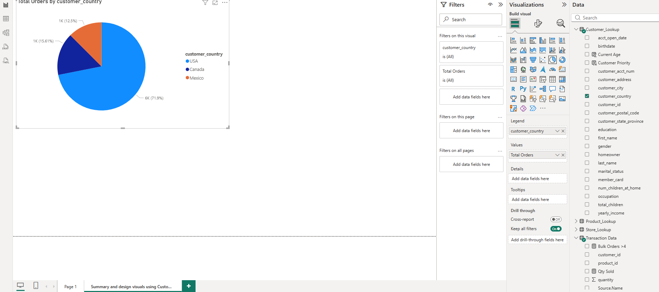

A Bar Chart showing Total Orders by State
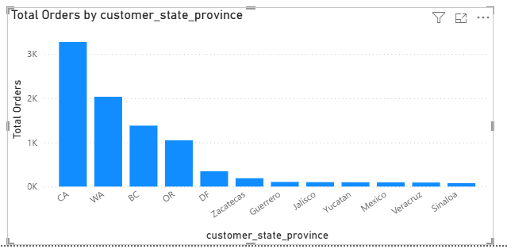
A Matrix displaying Product Names, Qty Sold, and Total Orders
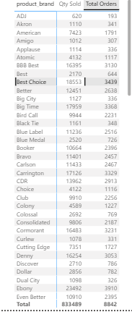

A 123 Card showing Qty Sold, Total Orders, and Total Orders by Gender

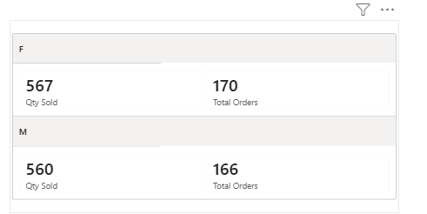

Slicers for Gender, Country, Store Type, and Store City
